Project Completion Report 2020 Cycle

SOCIAL ENTREPRENEURSHIP TRAINING PROGRAMME FOR WOMEN IN THE HORN
OF AFRICA

DIVISION FOR PROSPERITY
June 2021, Hiroshima, Japan



Project Completion Report 2020 Cycle

SOCIAL ENTREPRENEURSHIP TRAINING PROGRAMME FOR WOMEN IN THE HORN
OF AFRICA

DIVISION FOR PROSPERITY
June 2021, Hiroshima, Japan



Acknowledgements
The United Nations Institute for Training and Research would like to express its deep gratitude to the following supporters of UNITAR Social Entrepreneurship Training Programme for Women in the Horn of Africa.

- The Government and the People of Japan

We would like to also recognize:

- United Nations Development Programme (UNDP), Ethiopia
- UNDP Kenya
- UNDP Somalia
- UNDP Sudan
- United Nations Office for Coordination of Humanitarian Affairs, Somalia
- Ethiopia Permanent Mission to the United Nations in Geneva
- Kenya Permanent Mission to the United Nations in Geneva
- Somalia Permanent Mission to the United Nations in Geneva
- Sudan Permanent Mission to the United Nations in Geneva
- Hiroshima Prefectural Government
- The City of Hiroshima

Our special thanks go our resource persons and participants who contributed their time and expertise to the programme so graciously.

Finally, we would like to thank the people of Hiroshima, whose support was indispensable for the success of the 2020 cycle of the programme.



“The course and the methodology used were effective and I highly appreciate the team for making the course accessible without any major difficulties for me."

About Us

United Nations Institute for Training and Research
UNITAR was established in 1963 as an autonomous body within the United Nations and is headquartered in Geneva, Switzerland. As a training arm of the United Nations system, UNITAR provides innovative learning solutions to individuals, organizations and institutions to enhance global decision-making and support country-level action for shaping a better future. UNITAR designs and conducts some 500 different global training activities per year for more than 133,000 participants. Our alumni include diplomats and other government officials, non-governmental representatives, and local authorities.

UNITAR, Division for Prosperity
The Division for Prosperity is one of the eight divisions of UNITAR and consists of the Trade and Finance Programme Unit and the Hiroshima Office. We offer cutting-edge training and learning opportunities that promote inclusive and sustainable economic growth.

The Division for Prosperity programmes fall under six thematic pillars that support the Sustainable Development Goals (SDGs):
- Anti-corruption and Combatting Crime
- Entrepreneurship and Private Sector Development
- Finance and Trade
- Frontier Technologies
- Hiroshima and Peace
- Leadership and Empowerment

Leveraging our Division’s extensive experience in designing relevant and targeted training, we adapt our methodologies and technologies to the needs of the regions and individuals we serve. We work with learners in least developed countries, small island developing states, and fragile states, with special attention to the most vulnerable including women, youth, and those in conflict situations.




Mihoko Kumamoto
Director
Hiroshima Office, Division for Prosperity
United Nations Institute for Training and Research



Contents
Acknowledgements 3
About Us 4
Executive Summary 6
Lessons Learned 8
Programme Summary 9
Programme Structure and Methodology 10
Strategic Alignment: Sustainable Development Goals 14
Outcomes 15
Effectiveness of the Programme Methodologies 22
Lessons Learned 23
Annex I 29
Annex II 31

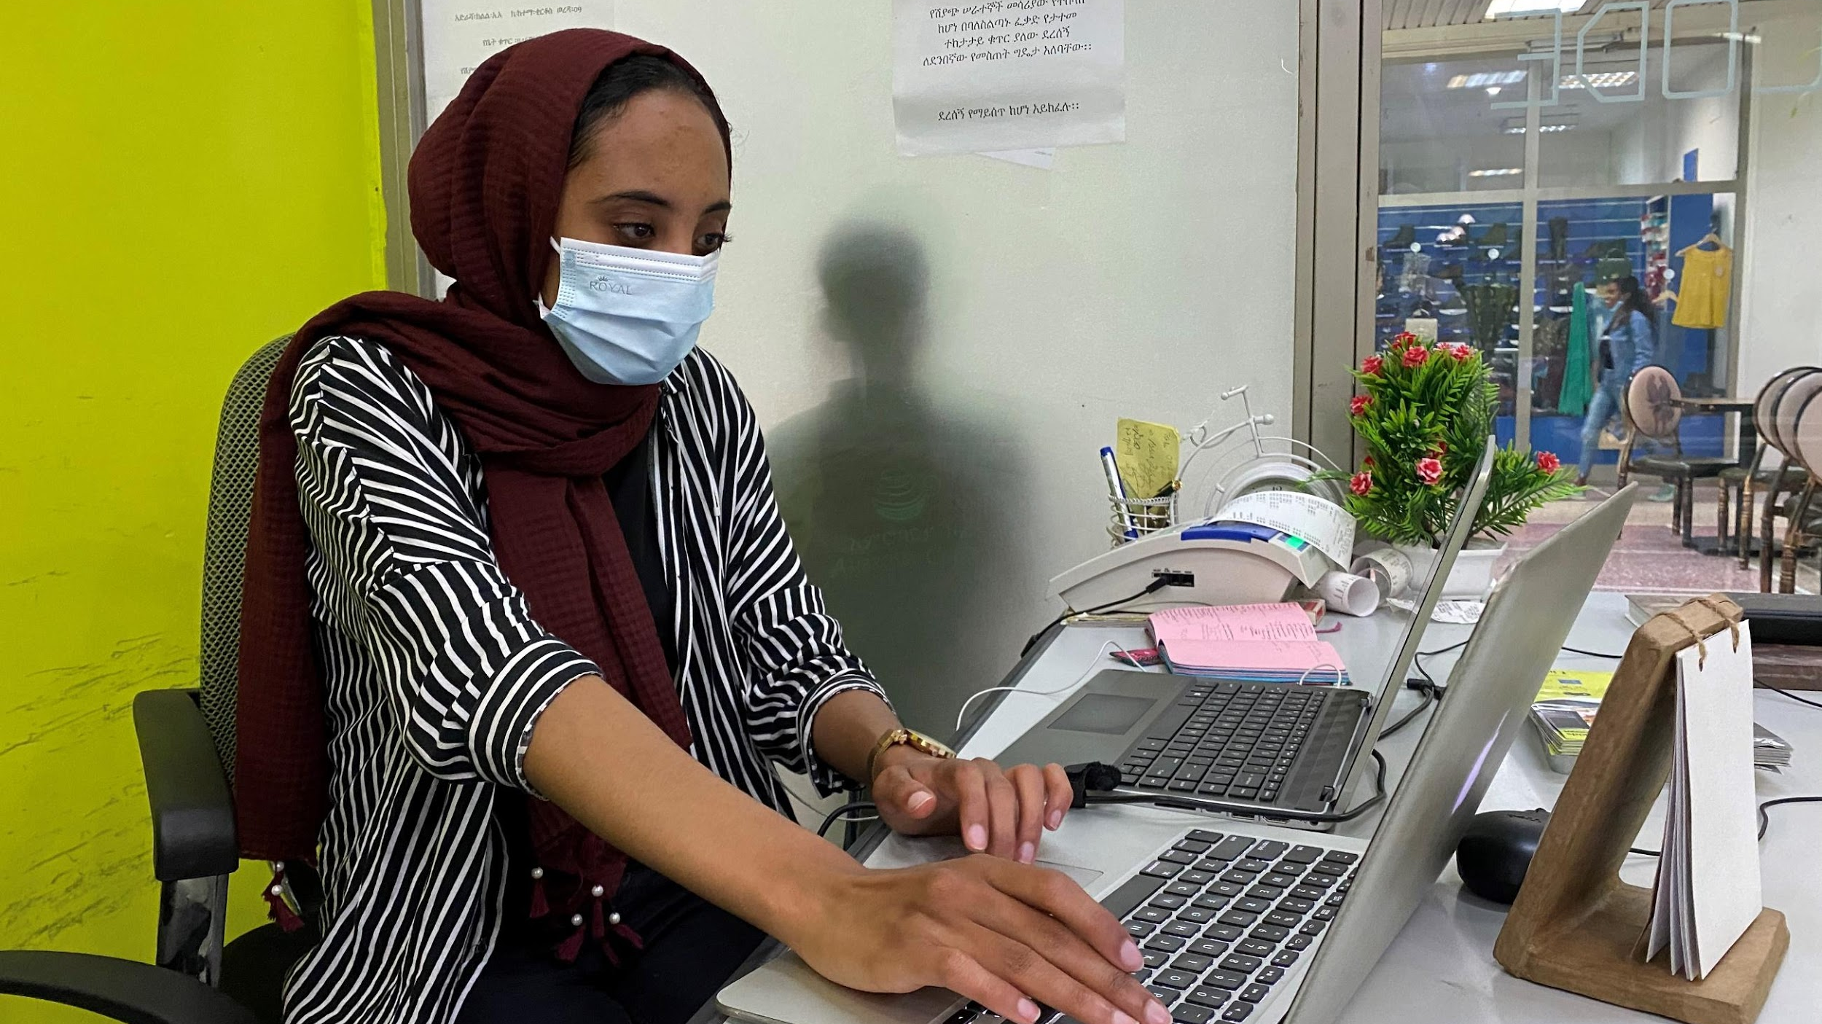
COURTESY OF SITRA ABUBAKER

Executive Summary
The COVID-19 pandemic has posed unprecedented challenges to the people around the world, especially in the areas of public health, and threatened millions of jobs and livelihood opportunities, with huge socioeconomic implications. The pandemic is likely to reverse much of the progress made towards the Sustainable Development Goals (SDGs), including in the Horn of Africa (HoA), and further exacerbate youth unemployment, poverty, social inequality, and climate change.

Entrepreneurship and social entrepreneurship have the potential to promote socioeconomic development and help the world “build back better.” When women have knowledge and skills in entrepreneurship, they can lead their own initiatives and businesses (social or commercial) and engage more meaningfully in their societies.

Thus, this programme was exclusively designed for women entrepreneurs and leaders from the HoA, focusing on entrepreneurship, social entrepreneurship, leadership, and innovation, with the generous financial support of the Government and People of Japan.

The programme was delivered entirely online due to the pandemic and subsequent lockdown measures. However, we made the utmost effort keep the programme interactive, such as by forming learning communities and using the microlearning platform EdApp.

Programme Participants
The online programme trained 182 aspiring and passionate women entrepreneurs from Ethiopia, Kenya, Somalia and Sudan in phase 1 and 65 in phase 2. The participants were selected through an open call for applications to the public sector, private sector, academic institutions, and civil society organizations.

Programme Structure
The programme’s two-phased approach helped the participants develop their entrepreneurial skills and capacity to address local needs through innovative and creative business solutions. Phase 1 focused on the fundamentals of entrepreneurship and innovation; Phase 2 went deeper into leadership, strategy, and innovation. The programme was delivered through self-paced online modules on the microlearning platform EdApp, in combination with live webinars and local coaching and mentoring support. It encouraged peer learning and knowledge sharing, and supported the formation of a network of like-minded female entrepreneurs in the HoA.

“I learnt about the reconstruction of Hiroshima and believed that rebuilding cities destroyed during wars is very possible. It’s a role model for countries recovering from civil and terrorism wars like Somalia.”
—HODAN OMAR
Somalia

“The course was life changing. It changed my worldview of entrepreneurship and leadership. The training has significantly contributed to the development of my new projects. I am more innovative and effective thanks to UNITAR.”
—BETTY MBITHI
Kenya

Thirty-one coaches, who are experts on entrepreneurship, provided each participant with regular feedback, mentoring, and guidance. They were an invaluable addition to the programme as they shared their own experience in running business projects, and helped participants to contextualize the course content to the changing needs in the HoA.

Outcomes
The overall learning outcomes of the HoA participants were highly satisfactory. In both phases of the programme, participants showed high rates of course completion: 63% of the Phase 1 learners and 59% of Phase 2 learners completed more than 85% of the course. Current research finds that average completion rates for online courses range between 0.7% to 52.1%, with a median value of 12.6%. The shows us that the completion rates for this programme were excellent.

The high completion rates were likely influenced by the interactive course design that encouraged participant engagement. The UNITAR team also provided robust oversight and clear communication with participants, responding to daily inquiries and resolving issues in a timely manner.

Another key component was the coaching and mentoring provided by UNITAR alumni from Afghanistan, Iraq, and South Sudan. The coaches provided feedback on the assignments, shared their insights to contextualize the learning, offered regular support, and animated the discussions, thus encouraging meaningful participation.
Highlights of the Programme

The overall programme was highly interactive and engaging, including the following key components:
- The microlearning platform EdApp allowed participants to complete self-paced microlessons in their own time and space without risks associated with COVID-19.
- Expert videos, guidebooks, and additional resources augmented the self-paced online lessons to enrich the learning.
- Group assignments gave participants the opportunity to collaborate with their peers, encouraging cooperation and networking.
- Weekly group discussions with peers and the coaching team allowed participants to network and exchange HoA-specific knowledge and information.
- Technologies such as Zoom and EdApp allowed the participants to learn and work with world-class experts through webinars and live sessions.
- Learning communities allowed participants to engage with each other, discuss how to overcome existing challenges and seize new opportunities presented by the pandemic, and support each other beyond the completion of the programme.
- .
COURTESY OF SAMAH ALGADI

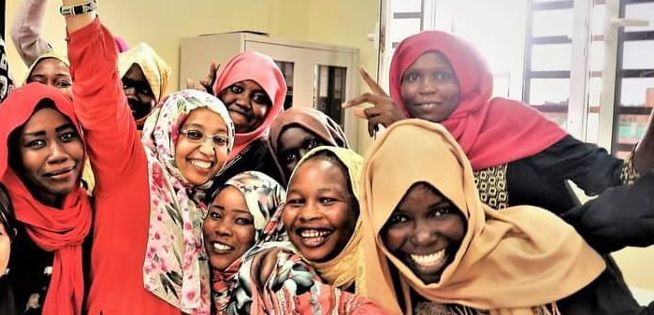

Lessons Learned
The online delivery allowed HoA women entrepreneurs to connect and learn safely and also expanded and diversified the participant pool. Participants brought a wide range of cultural, geographical, and professional backgrounds that enriched the learning. They engaged and formed trusting friendships in a network of like-minded HoA women – connections that are key for early-stage entrepreneurs and business leaders.

Engagement with experts and role models also proved memorable. Participants were especially inspired by Prof. Linda Hill, professor of business administration at Harvard Business School and chair of the Leadership Initiative and an African American woman.

- “I will never forget her webinar. Her questions such as ‘why are you here in this meeting?’ gave me a very quick flashback of what I want to do and how I am going to do it.”
- “Every explanation was remarkable. I cannot get it out of my mind how she mentioned that everyone has a ‘slice of genius.’ We should believe in ourselves and try to embrace it.”

Our commitment to inclusion and sustainability resonated with potential partners: Unilever Kenya has joined us as a partner and will add valuable insights to our future programmes to empower aspiring young female entrepreneurs in Africa.

Delivering a fully online programme inevitably had some drawbacks. Unstable internet disrupted the learning, and future programmes will need to strategize how to address this real problem. UNITAR may also want to consider an online/in-person hybrid programme, especially as collaborating and networking are key for early-stage entrepreneurs.

There is also scope to provide more local and regional information and examples. For future iterations of the programme, UNITAR will build more local and national partnerships with incubators and accelerators and develop more local and regional case studies.
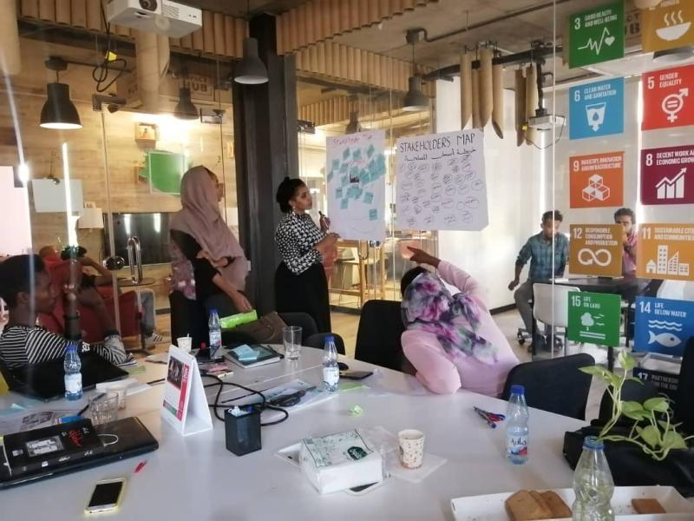
COURTESY OF NADIA ABDALLA

“The experience was very insightful, with a powerful mix of expert instructions and peer learning which provided me with practical knowledge in social innovation. There were many case studies in the African setting and this affirmed that it can be done.”
—HEIDI MUMIA
Kenya
COURTESY OF ATHRAA AKRAM SABRI

COURTESY OF SAMAH ALGADI

Programme Summary
The COVID-19 pandemic has posed unprecedented challenges to the people around the world, especially in the areas of public health, and threatened millions of jobs and livelihood opportunities, with huge socioeconomic implications. The pandemic is likely to reverse much of the progress made towards the Sustainable Development Goals (SDGs), including in the Horn of Africa (HoA), and further exacerbate youth unemployment, poverty, social inequality, and climate change.

Entrepreneurship and social entrepreneurship have the potential to promote socioeconomic development and help the world “build back better.” When women have knowledge and skills in entrepreneurship, they can lead their own initiatives and businesses (social or commercial) and engage more meaningfully in their societies.

Thus, this programme was exclusively designed for women entrepreneurs and leaders from the HoA, focusing on entrepreneurship, social entrepreneurship, leadership, and innovation. It was made possible with the generous financial support of the Government and People of Japan.



“During tribal conflicts and the outbreak of the Corona pandemic, the experience was for me a safe that contained all my aspirations and ambitions and built me ​​a new hope in achieving my goals and supporting me in advancing my community in the field of entrepreneurship and reflecting its importance in supporting the economy.”

YASMIN ELAMIN MAHGOUB ELAMIN
Activist in civil society
Sudan

2021 Cycle Participants
The 2021 programme – consisting of two stand-alone phases, or courses – was delivered entirely online, due to the challenges posed by the COVID-19 pandemic.

In Phase 1, which focused on the fundamentals of entrepreneurship and innovation, a total of 182 women from Ethiopia (31%), Kenya (30%), Somalia (20%) and Sudan (19%) were trained.

By sector, 13% were from the private sector, 12% from non-governmental organizations, 22.0% from each country’s government sector (including 17 participants from central government, two from state government, and one from local government). Others were from academia and international organizations.
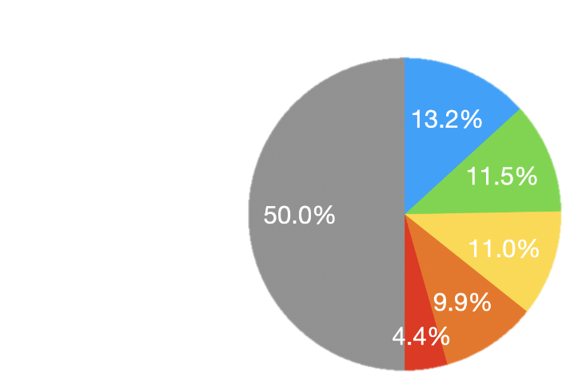
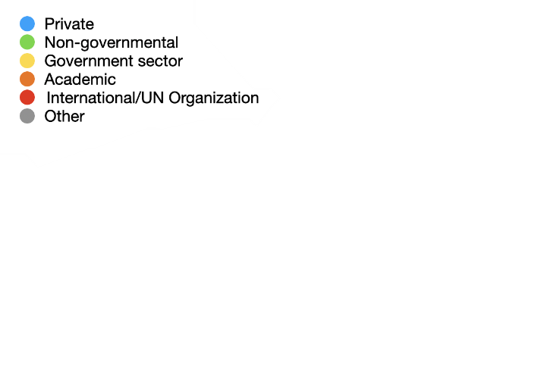

Phase 1 Participants: Sectors
In Phase 2, which focused on leadership, strategy and innovation, 65 women from Kenya (43%), Ethiopia (29%), Sudan (22%) and Somalia (6%) were trained.

By sector, 49% were from the private sector, 17% from non-governmental/non-profit organizations, and 9% from academia. Others were from governmental organizations, international/UN organizations, students, and others.

Programme Structure and Methodology
The 6-month programme had two phases, which helped participants to effectively develop their knowledge and skills and reach each learning objective.

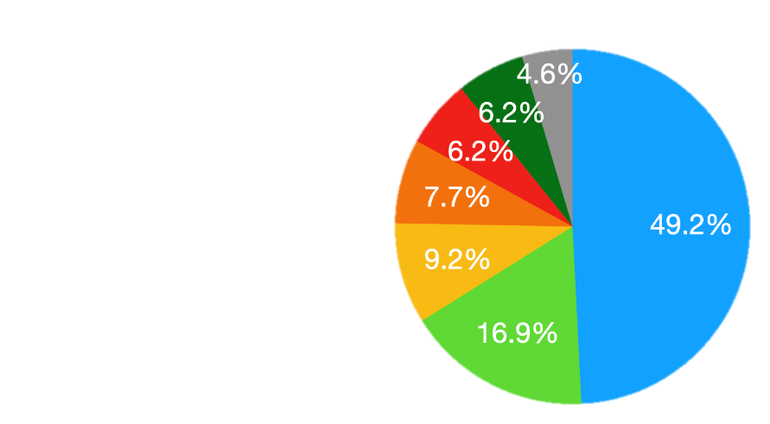

Needs Assessment

Phase 2 Participants: Sectors
UNITAR conducted an initial needs assessment with the participants to ensure that the programme’s learning objectives and modules were in line with the latest regional and global trends and aligned with the participants’ needs. The assessment also included an evaluation of UNITAR other programmes, consultations with our international, regional partners, and literature review.

Phase 1: The Fundamentals of Entrepreneurship and Innovation
Assignments for Phase 1: The Fundamentals of Entrepreneurship and Innovation

- Case Study on a Social, Not-for-Profit or Commercial Enterprise
- Value Proposition
- Designing the Business Model
- Demand Creation Strategies

Learning Communities for the Fundamentals of Entrepreneurship and Innovation

LC1: Agriculture, Food Processing, Horticulture, Energy, Renewables and Rural Development
LC2: Retail and Craft Industries, Arts, Entertainment and Recreation
LC3: Information, Media, Information Technology, including Software, Robotics, 3D Printing, AI and other Frontier Technologies
LC4: Health, Well-being and Social Assistance
LC5: Social Entrepreneurship, including Sanitation, Water Provision, Social Entrepreneurship Hubs and Incubators
LC6: Professional, Scientific and Technical Services including Logistics, Supply Chain, Waste Management

Phase 1 consisted of a ten-week course called the “Fundamentals of Entrepreneurship and Innovation.” Using the microlearning platform EdApp, the participants completed three on-demand modules with over 33 lessons and four assignments, submitted one post per week to the discussion space on EdApp, and took part in two live webinars to receive UNITAR Certification.

For both phases, participants joined a learning community of their choice, aligned with their working sector and/or area of expertise. Each learning community held weekly discussions to facilitate interaction and collaboration among participants with similar interests and struggles.
Assignments for Phase 2: Leadership, Strategy and Innovation

- Reflective Learning Log #1: Sharing one personal or professional experience to reflect on
- (Group/Individual) Competitive Strategy
- Innovation Programme Framework
- Reflective Learning Log #2: Sharing one personal or professional experience to reflect on

Phase 2: Leadership, Strategy, and Innovation
Phase 2 consisted of an eight-week course called “Leadership, Strategy, and Innovation,” which was run online between January to March 2021 with 65 participants chosen from Phase 1.

To qualify for Phase 2, participants from the Fundamentals of Entrepreneurship and Innovation phase could apply by submitting a digital pitch. The 65 finalists were chosen through a competitive selection process. This select group of participants completed three EdApp self-paced modules with over 31 lessons, five live webinars, and three assignments. The participants were divided into three learning communities, in which they held weekly discussions and completed assignments.

Learning Communities for Leadership, Strategy and Innovation

LC1: Not-for-Profit or Social Enterprises
LC2: For-Profit, Micro, Small and Medium Enterprises (SME)
LC3: Large/Multinational Organizations, Academic or Public Sector Organizations

Learning Objectives

The key learning objectives of the programme were to:
- Evaluate (social) entrepreneurship in the context of the Horn of Africa’s sustainable growth and development
- Appraise their own entrepreneurial and leadership style and motivations
- Implement a design thinking methodology to identify and solve problems or needs through (social) entrepreneurship and innovation
- Apply frontier technologies such as AI, robotics, and the internet of things to the creation of new enterprise for the betterments of individuals, society and the environment
- Outline key elements of stakeholder identification integration, engagement and enrolment in financing new ventures, building partnerships and the co-founding team
- Apply impactful communication techniques to various contexts
- Resolve social and environmental challenges through social entrepreneurship and innovation
- Discuss the key components of the SDGs
- Explore the post-war reconstruction of Hiroshima in close cooperation with local authorities and institutions in Hiroshima
- Outline existing opportunities and challenges in promoting gender equality

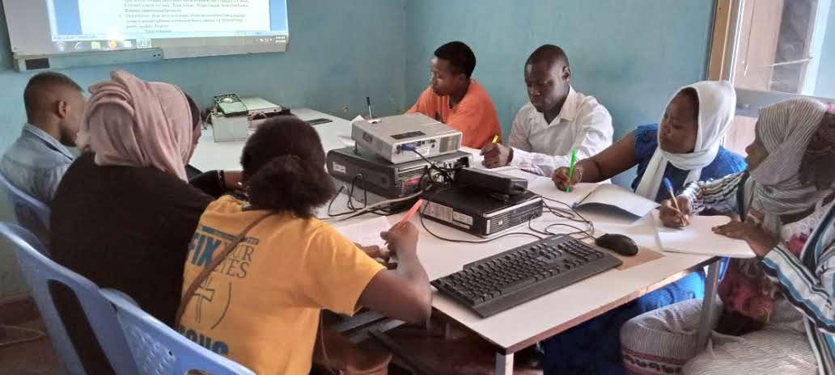
COURTESY OF BETTY MBITHI

Programme Modules

Phase 1: The Fundamentals of Entrepreneurship and Innovation

Phase 2: Leadership, Strategy and Innovation

“The information presented in this course was totally new to me. The course was full of skills that I have been looking for. I greatly appreciate the outstanding effort of the UNITAR team. (post-delivery survey)”

Regional Coaches and Mentors

“During this hard time of COVID-19, I am very glad to get this golden opportunity to learn about entrepreneurship and innovation. It will help me boost my career. Many thanks to UNITAR.”
Local and regional experts on entrepreneurship and leadership were assigned to each learning community. Through EdApp, the coaching team provided regular feedback to the participants and shared their own experiences and insights. Phase 1 had 31 coaches and Phase 2 had 15 coaches. All coaches were volunteers who had completed previous UNITAR programmes in Afghanistan, Iraq, and South Sudan. They underwent additional training before serving as coaches.

International Experts
Clare Gately, Professor, Entrepreneurship and Innovation, Waterford Institute of Technology (Ireland), led and oversaw the design, implementation, and evaluation of the entire programme. A leading expert in innovation and entrepreneurship, she helped develop the course content, coaches’ guidelines, participants handbooks, digital content, and case studies.

Two other renowned experts were invited to give webinars on leadership and team development:
- Linda Hill, Professor of Business Administration, Harvard Business School, and chair of the Leadership Initiative (US)
- Michael A. Fors, Executive Leader, Corporate Division and Business Development Unit, Boeing (US)

Strategic Alignment: Sustainable Development Goals
In accordance with the United Nations 2030 Agenda for Sustainable Development, this programme meaningfully contributes to the following SDGs:



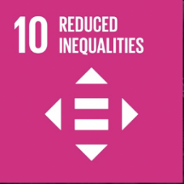
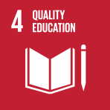
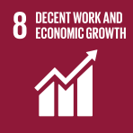


Outcomes
The Key Takeaways for Participants

The participants learned the following in each phase:

Phase 1: The Fundamentals of Entrepreneurship and Innovation
- The entrepreneurial process of identifying opportunities and mobilizing resources to bring a new enterprise to life
- Tools and techniques of design thinking and lean start-up to create desirable, feasible, viable, and sustainable solutions that solve customer needs and problems
- How to design a business model appropriate for their enterprise and customer segment(s)
- How to develop and evaluate revenue models to capture value in all its forms and formulate financial projections appropriate for social or commercial enterprises

Phase 2: Leadership, Strategy and Innovation
- Contemporary theories and practices of leadership, teambuilding, and teamwork
- The tools and techniques of competitive and risk-mitigating strategies
- How to decode and apply the many types of innovations that lead to competitive advantage and enterprise growth

At the end of each phase, participants completed online evaluations of the programme. The Phase 1 survey consisted of 30 questions, and the response rate was 87%. The Phase 2 survey consists of 10 questions, and the response rate was 100%. Other outcomes were measured using data from the EdApp platform.

The participants’ evaluations measure relevance, individual satisfaction, and engagement. The minimum target is positive feedback from more than 70% of the participants.

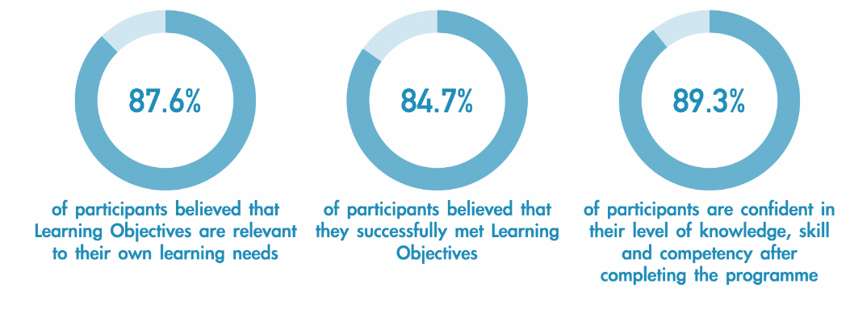
Relevance
The participants evaluated the relevance of the programme’s learning objectives (see page 12) to their own learning needs, on a scale of 1 (“Not all all”) to 5 (“Fully”).

88%
of participants believed that the objectives were relevant to their learning needs

For Phases1 and 2 combined, 88% of the participants agreed that the programme learning objectives were relevant to their learning needs. This exceeded the minimum target of 70% for all learning objectives, with the exception of Objective 4 (“Apply frontier technologies,” 64%). The response was remarkably positive on Objective 3 (“Implement design thinking,” 94%) and Objective 6 (“Apply impactful communication,” 93%).

Individual Satisfaction
The participants evaluated the extent to which they met each learning objective, on a scale of 1 (“not all all”) to 5 (“fully”).

Phase 1
On almost all objectives, more than 70% of the participants said they “mostly” or “fully” met the learning objective. Only Objective 4 (“Apply frontier technologies,” 58%) scored below the minimum target of 70%. The response was remarkably positive on Objective 3 (“Implement design thinking”), which scored 92%.

85%
of participants believed that they successfully met
the objectives
technology.

Objective 4, which focuses on frontier technologies including AI, may have scored low because the programme only provided the basics of AI. Frontier technologies is a highly complicated field and in-depth knowledge is needed to fully understand its application. Given this result, we are planning to develop a new course on AI and entrepreneurship that will offer a reasonably good foundation to understand the applications of the technology.

94%
of participants believed that they successfully met
the objectives

Phase 2
For Phase 2, 94% of the participants either agreed or strongly agreed that they met the learning objectives of the course.

Engagement

Knowledge levels before vs. after the programme
The participants were asked to evaluate their level of knowledge, skill, and competency for each learning objective before and after the programme, on a scale of 1 (“low”) to 5 (“high”).
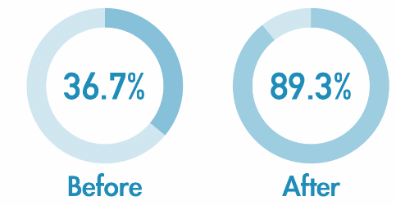

Knowledge Levels (Phase 1)
Before
After
37%
89%

Phase 1
Before the programme, 37% of participants answered that their knowledge levels were “moderate” or “high” across all learning objectives. After programme completion, this increased to 89%, an increase of 52 percentage points. The result was remarkable for Objective 1 (“Evaluate entrepreneurship in the your context”), which increased 64 percentage points, from 28% to 92%.
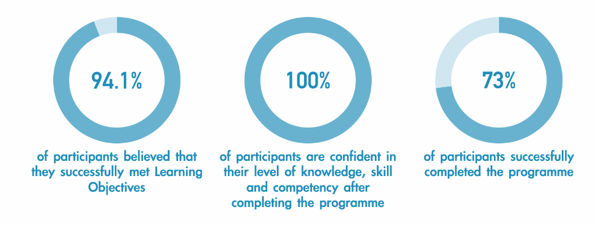

100%
of participants are confident in their level of knowledge, skills, and competency after completing the programme

Phase 2
Phase 2 participants were asked to evaluate their skills and knowledge of leadership, strategy, and innovation before and after the course. Notably, 100% of participants answered that their skills were either “moderate” or “high” after completing the programme, compared to 13% before the programme.

Time spent by participants
The amount of time each participant spent to complete the course was recorded through EdApp. The time spent depended on participants’ English language ability, level of motivation and commitment, and internet accessibility.

Phase 1
Phase 1 participants spent between 6 to 140 hours on the course. On average, participants spent 17 hours of active time to complete all necessary lessons. This does not include time spent on assignments and discussions.

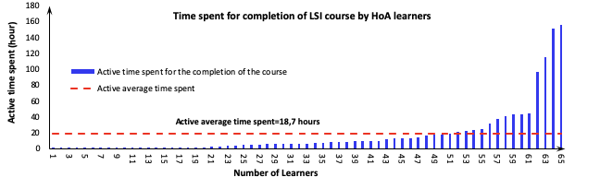
Time Spent to Complete Phase 1

Number of Learners
Active Time Spent (Hours)

18.7 hours was the amount of average active time spent overall on completing lessons in Phase 1

Phase 2
In Phase 2, participants spent on average 19 hours of active time to complete all necessary lessons, excluding time spent on assignments and discussions.

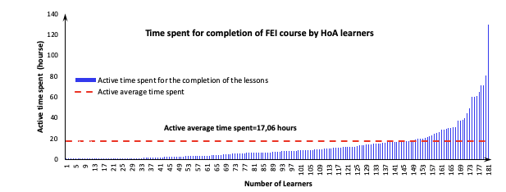
Time Spent to Complete Phase 2

Number of Learners
Active Time Spent (Hours)

19 hours was the amount of average active time spent overall on completing lessons in Phase 2

Completion Rate

"Thank you for the opportunity. I have learned a lot from this course, especially [about the] SDGs.”

Phase 1
In Phase 1, 63% of participants completed 85% of the programme and received a completion certificate.

Percentage of learners completed the course (%) | Number of learners that completed the course | Met completion criteria for UNITAR Certificate (%) | Certification
62.8 | 103 | 85 | Obtained Completion Certificate
64.4 | 106 | 75 | Obtained Participation Certificate
75 | 122 | 50 | Obtained Participation Certificate
83.5 | 137 | 33 | Obtained Participation Certificate

Phase 2
In Phase 2, 59% of participants completed 85% of the programme and received a completion certificate.

Percentage of learners completed the course (%) | Number of learners that completed the course | Met completion criteria for UNITAR Certificate (%) | Certification
59.3 | 35 | 85 | Obtained Completion Certificate
64.4 | 38 | 75 | Obtained Participant Certificate
74.6 | 44 | 50 | Obtained Participant Certificate
76.3 | 45 | 33 | Obtained Participant Certificate

Current research shows that average completion rates for online courses range between 0.7% to 52.1%, with a median value of 12.6%. This shows us that the completion rates for this programme were excellent.

Job Relevance, New Information, Intent to Use, and Overall Usefulness

“The webinars were very informative, and the lecturers were very motivated, which affected us very positively. Also, I thank the coaches for being helpful and responsive!”
UNITAR standard programme evaluation indicators include “job relevance,” “new information,” “intent use” and “overall usefulness.” The UNITAR minimum target is to receive positive feedback from more than 70% of the participants. For each question, the participants were asked to rate their opinion on a scale of 1 (“strongly disagree”) to 5 (“strongly agree”).

Phase 1 Results | Phase 2 Results
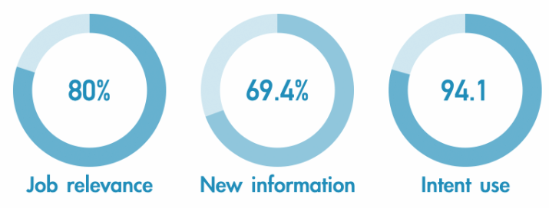  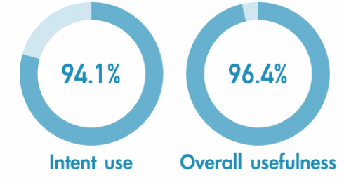  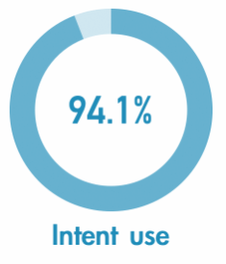  90%  Job Relevance  66%  New Information  100%  Intent to Use  100%  Overall Usefulness  80%  Job Relevance  69%  New Information  94%  Intent to Use  96%  Overall Usefulness | 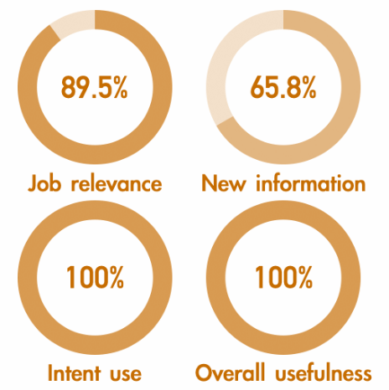


COURTESY OF CANDY OBUNGA

Job relevance
Job relevance evaluates to what extent the programme was relevant to the participant’s professional roles. Participants were asked whether they agreed with the statement “The content of the course was relevant to my job.”

Phase 1
80% of the participants either agreed or strongly agreed, with the weighted average of 4.21.

Phase 2
90% either agreed or strongly agreed, with the weighted average of 4.47.

New information
New information evaluates to what extent the programme imparted new knowledge to the participants. Participants rated the statement: “The information presented in this course was new to me.”

Phase 1
69% either agreed or strongly agreed with this statement, with the weighted average of 3.88.

“I am so glad to be part of this programme. I learnt a lot and initiated a networking breakfast with a number of colleges in Nairobi. The content was very useful, and the webinars were the best part of the programme for me. The speakers were fantastic – their expertise, high level of information and passion were insightful and inspiring.”

Phase 2
66% either agreed or strongly agreed with this statement.
The feedback on “new information” did not reach the target minimum value of 70%.

Intent to use
Intent to use evaluates to what extent the participants intend to use their newly acquired knowledge. Participants rated the statement: “It is likely that I will use the information acquired.”

Phase 1
94% either agreed or strongly agreed with this statement, with the weighted average of 4.60.

Phase 2
100% either agreed or strongly agreed with the statement.

Overall usefulness
Overall usefulness evaluates the extent to which participants saw the programme as useful and was assessed by the statement: “Overall, the programme was useful.”

Phase 1
96% of the participants either agreed or strongly agreed with this statement. In addition, 94% either agreed or strongly agreed that they would recommend this course to colleagues or friends.

Phase 2
100% either agreed or strongly agreed with this statement; 100% also either agreed or strongly agreed that they would recommend this course to colleagues or friends.

The responses to “Job relevance” and “Intent to use” exceeded the UNITAR minimum target of 70% positive feedback, which allows us to conclude that the programme provided a helpful learning experience aligned with the participants’ professional roles and needs.

However, the response to “New information” was below the target. In the next cycle, UNITAR may need to modify the content to deliver more new information.



“The course was very valuable and applicable to my work. I have already started implementing the information in my social enterprise, and I am seeing great results. I am truly grateful for the Japanese Government and the UNITAR team for giving us this golden opportunity and equipping us with knowledge and skills which will scale up our enterprise.”
COURTESY OF MELAT GEBREGIORGIS WELDEEYESUS

Effectiveness of the Programme Methodologies
Participants were asked to rate the following five statements on a scale of 1 (“strongly disagree”) to 5 (“strongly agree”):
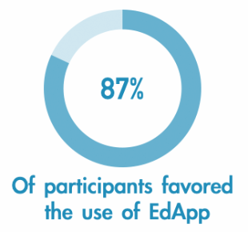
- The programme was effective at using EdApp as a mobile microlearning platform to impart new knowledge, tools and resources to learners

87%
of participants preferred
using EdApp
- The programme was effective at responding to questions of learners
- The programme was effective at stimulating learner engagement in online discussions and webinars
- In-lesson assessments and assignments were useful to help you achieve the learning objectives
- The programme’s methodology was useful given the learning objectives

Phase 1
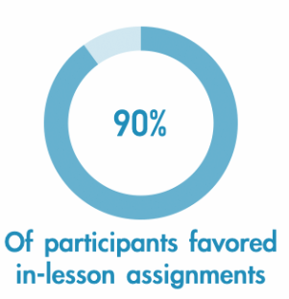
More than 70% of the Phase 1 participants agreed or strongly agreed that the methodologies were effective, except for the statement “The programme was effective stimulating learner engagement in online discussions and webinars.”

90%
of participants preferred in-lesson assignments

In particular, 87% of the participants answered positively on the use of the EdApp mobile learning platform; 90% indicated that the in-lesson assessments and assignments were useful

Phase 2
Among Phase 2 participants, on average, 95% either agreed or strongly agreed that the programme’s methodology was useful, given the learning objectives.



COURTESY OF SITRA ABUBAKER

Lessons Learned
The 2020 programme was completed successfully despite pivoting to a fully online course, due to the COVID-19 pandemic. UNITAR identified the following opportunities and challenges for future iterations of the programme.

Opportunities
- The Horn of Africa context is conducive to entrepreneurship and social entrepreneurship
  - HoA has thriving social and business networks. Throughout the 2020 programme, participants utilized social media to spread awareness of the programme and of their own related activities. Social networks are also highly relevant to entrepreneurship and social entrepreneurship, where sharing information about an organization, service or product, as well as interaction with the community an organization is servicing, is critical to an enterprise’s effectiveness and success. The HoA’s young population is well suited to use the new technologies and social networks in the country to address their communities’ numerous and evolving needs through social entrepreneurship.

- Online training creates new opportunities to connect and learn in times of uncertainty while expanding and diversifying the participant pool in the HoA.
  - Transforming an in-person training to a fully online one was complex and time-consuming, but it helped to significantly increase the number of people UNITAR could reach..
  - Participants could learn at their own pace and timing without any travel and infection risks. Unlike in-person trainings, online learning made it easier for participants in rural areas to join. By bringing together youth from various geographical regions, the online programme promoted diversity and connect different cultural groups to exchange ideas and information – connections that are key for early-stage entrepreneurs and business leaders.
  - UNITAR will continue using such methodologies and new technologies to reach and connect more learners, while adhering to well established online-training practices to maintain training quality.

- The blended learning modality helped to implement the programme effectively with excellent completion rates.
  - The programme’s blended learning modality offered an interactive and engaging environment of learning and sharing by combining self-paced modules – including microlessons, assignments, and discussion posts – with live webinars and coaching and mentoring support. Content was presented incrementally in bite-sized microlessons with built-in exercises so that participants could absorb the information. Learning was reinforced through weekly assignments and interactions with peers and world-class experts. Local coaches offered regular support and animated the discussion; they facilitated meaningful participation.
  - The blended design helped the programme run smoothly and effectively despite the uncertainties caused by the pandemic. Participants showed high levels of commitment, completing the course modules and assignments, engaging in group discussions, and recording their video pitches. The course achieved excellent completion rates.

- National and regional experts familiar with the local situation helped to contextualize the learning content to HoA.
  - National and regional coaches and mentors from Afghanistan, Iraq, and South Sudan were invaluable in relating the programme content to the current situation in HoA. They provided local examples and knowledge from running their own projects. The coaches enriched the learning environment by facilitating the discussion forum on EdApp, reviewing assignments, and providing regular and timely feedback to the participants. Local expertise is indispensable when working in conflict-affected areas, and the coaches and mentors helped make the programme highly relevant to the participants’ needs.

- The diverse, multi-sectoral group of participants encouraged peer learning and collaboration.
  - Participants brought diverse knowledge and experiences to the programme, and engaged through the learning communities. The multi-sector mix enriched the programme and proved effective in building trust and friendship and a network of like-minded HoA youth.
COURTESY OF BEATRICE KWAMBOKA
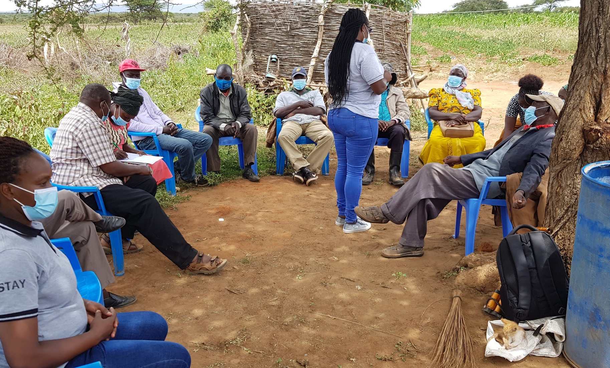
  - Furthermore, public-private partnerships are essential to long-term economic stability and growth in HoA, as the public sector is responsible for creating an environment in which entrepreneurship and social entrepreneurship can flourish. Such an environment can have a tangible positive impact on the socioeconomic development of HoA society.
- The live webinar by Prof. Linda Hill provided invaluable encouragement to participants with entrepreneurial aspirations and careers.
  - As a professor of business administration at Harvard Business School and chair of the Leadership Initiative in the US, Prof. Linda Hill is a leading figure in the innovation and entrepreneurship field. Her live webinar was very well received by the HoA participants. Her extensive teaching experience with young female entrepreneurs, as well as her background as an African-American woman, inspired many of the HoA participants to pursue their passion and hold a strong will to realise their dreams.
  - Some reflections from the participants on her webinar:
    - “I will never forget her webinar. Her questions such as ‘why are you here in this meeting?’ gave me a very quick flashback of what I want to do and how I am going to do it.”
    - “Every explanation was remarkable. I cannot get it out of my mind how she mentioned that everyone has a ‘slice of genius.’ We should believe in ourselves and try to embrace it.”
    - “I learned from Prof. Hill we need to be a ‘game-changer’!”

- The inclusive design of the programme and its main focus on business sustainability attracted new partners in the region.
  - The programme embraced the diverse interests and needs of HoA women, with an inclusive approach that respects the unique character of each woman and encourages them to nourish their talent. By empowering female entrepreneurs who will make an impact in their countries, the programme contributes to just sustainability. Our commitment to providing equal and valuable opportunities for all passionate women and our focus on the sustainability of new and existing businesses resonate with many potential partners and stakeholders.
  - In particular, Unilever Kenya has joined hands with UNITAR as a key partner. Unilever's years of commitment to a sustainable future will surely add valuable insights to our future programmes to empower aspiring young female entrepreneurs in Africa.
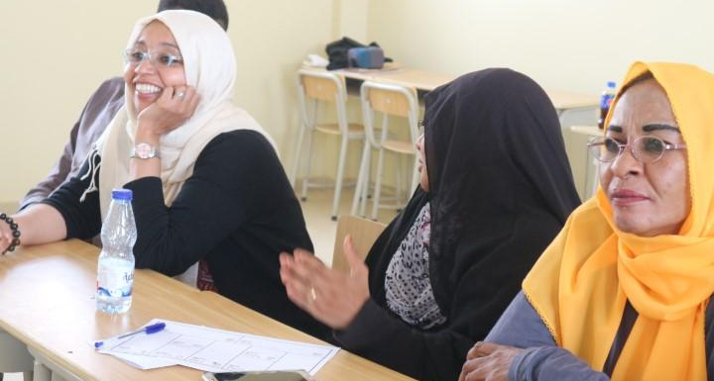
COURTESY OF SAMAH ALGADI

Challenges
- The overwhelming majority of the programme participants suggested that a hybrid modality that includes some in-person engagement would be better than 100% online training.
  - Delivering a fully online programme had tangible benefits including reaching participants from disadvantaged groups and rural communities. However, the participants indicated that in-person learning could have improved their chances to collaborate and materialize their business ideas. In-person learning provides better opportunities to engage, interact and, most importantly, to network and collaborate. These are especially important for early-stage entrepreneurs and business leaders and cannot be taken lightly.
  - For the future, UNITAR may wish to consider a hybrid modality that combines online and in-person training modalities. One suggestion is to use a two-phased approach, where participants complete the online modules through EdApp in the first phase; in the second phase, selected top participants with tangible business ideas could meet in person, where they receive targeted coaching and mentorship to materialize their ideas.

- Technical problems and poor internet connectivity can disrupt online training.
  - Both participants and the UNITAR admin team experienced technical difficulties during the programme implementation. Every day, 5-15 participants would contact UNITAR: their internet connections were interrupted so frequently that they could not actively engage in webinars, upload assignments, or watch course videos, etc. Such technical problems are critical and difficult to avoid. Since many participants are in fragile states and internet connectivity differs by location, future cycles may need to prepare strategies to address such technical limitations.

- Sustaining participants’ engagement can be more challenging in online training compared to in-person training.
  - One of the key challenges with self-paced online learning is that learners need a higher level of personal motivation and commitment to complete the course. In online courses, it is easier for participants to lose interest and dropout. In webinars, participants tend to be more passive compared to in-person sessions, where reactions of others are sensed easily. It is even more difficult when participants have to turn off their webcams because of their low bandwidth.
  - Although the UNITAR programme provided forums for discussions and Q&A as much as possible, as well as group work during the live webinars, some participants commented that they could have been more active if it were in-person training.



“Very grateful for being part of the UNITAR Leadership, Strategy, and Innovation Training Programme. I have learned that leadership is all about serving others, empowering people forward, and developing a team with integrity and vision. I've also been inspired by how rewarding experimentation over ego and having a diverse team is a great way of enhancing innovation. Thank you, UNITAR.”
AMEN SIME TADESSE
Team Lead at Abren
Ethiopia
- HoA participants were eager for more local information and regional case studies and examples.
  - While the course was carefully designed, the HoA participants were eager for even more local and regional information, such as how to find local support, attract funding for their initiatives, and specific market information, which were beyond the programme’s scope to provide. Furthermore, participants asked for more local and regional success stories and inspiring examples to further contextualize the learning to their own environments.
  - We could not prepare more local case studies and examples on short notice. For future iterations of the programme, UNITAR will build more local and national partnerships with incubators and accelerators to provide local knowledge and information. We will also extract data from EdApp to develop new local and regional case studies and examples and add them to the next iteration of the course.
- Coaches and mentors are volunteering their time and energy, and their full engagement cannot be guaranteed.
  - To sustain participant engagement and interest, UNITAR introduced national and regional coaches to minimize the risks of high dropout rates. The national coaches were provided with handbooks and referral notes and guidelines that emphasized their crucial role in regularly checking and maintaining the participants’ motivation. While EdApp data show that coaches were largely helpful in maintaining participant engagement, all coaches were working professionals who were volunteering for this programme. Although almost half of them actively carried out their duties and responsibilities, the remaining half did not.


“I experienced hands-on learning where the examples and reading materials were composed of events that occurred in the past. The courses also enabled me to think from different perspectives, mainly understanding the interaction between man, our planet, and profits. My favorite section was on design thinking. It showcased that creative thinking can systematic, and anyone can be creative.”
MARIAMAWIT SOLOMON KASSA
Project Coordinator
Ethiopia

- The diverse levels of participants’ prior knowledge and experiences make it challenging to design an effective programme that will satisfy every learner’s needs.
  - The varying levels of educational backgrounds, qualifications, prior knowledge and experiences needs to be carefully considered in the design phase of the programme and should be accommodated as much as possible. This gap was evident between, on the one hand, the Kenyan and Ethiopian participants and, on the other, the Sudanese and Somalian participants. The gap reflects context-specific conditions and realities and is unrelated to the talent of the Sudanese and Somalian participants.
  - UNITAR noticed this diversity among the participants early on, following the online call for applications, and a two-phased approach was adopted – where participants were introduced to the basics in Phase 1, followed by a deep dive in Phase 2 – to accommodate this diversity as much as possible. We also offered a range of assignments: some were easier, for learners with a modest level of knowledge and experience, and others were more challenging and required group effort and collaboration to complete.

- Time differences need to be considered for online delivery.
  - Time differences were another challenge for the programme implementation team. The programme was limited to HoA but with resource persons in the US and Ireland and UNITAR staff in Japan, it was a challenge to schedule webinars within acceptable hours for the learners and convenient to the resource persons. While online training can potentially increase the number of participants and participating countries, time zones of participants, experts and the admin team need to be considered in the future iterations of the programme.




“This was as eye opener opportunity that confirmed to me that 'Doors are opened for those bold enough to knock' greatly impacting my entrepreneurial background and the role I play in my society. It was a pillar for me to continue taking those bold steps and scale into even viable ventures. Thank you team UNITAR!”

WARUGURU KARIITHI
Social Entrepreneur
Kenya

“My experience with UNITAR has been fulfilling both personally and professionally, it helped me to expand my horizon and engage with people from around the globe.”

LINA K. GARELNABI
Architect
Sudan

Annex I

Programme Agenda
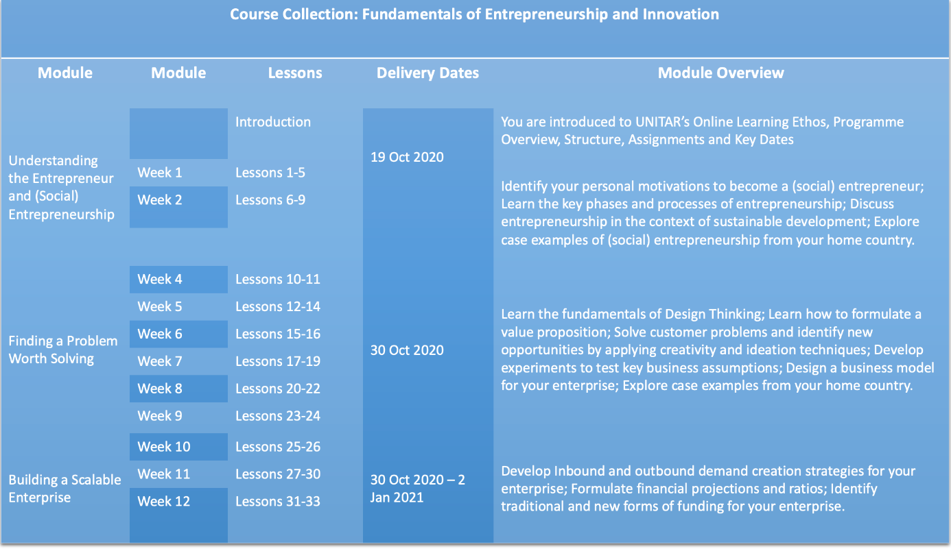
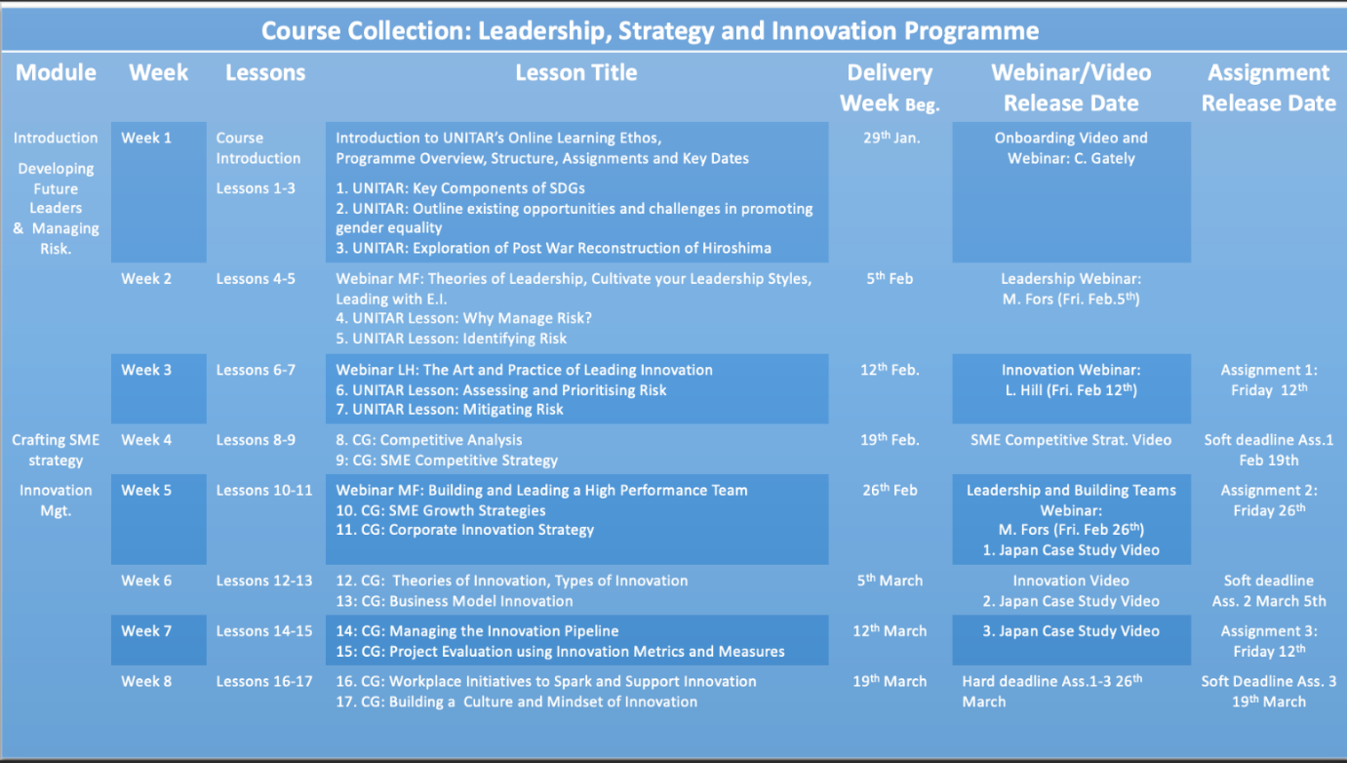

Annex II

Contribution to the 10 Core Values

The UNITAR Social Entrepreneurship Training Programme for Women in the Horn of Africa 2020 contributes to the following 10 Core Values of the Division for Prosperity.

Core Values | Additional explanation | Response
1) Generate Change Agents
Number of people trained |  | 247 female participants  (182 Phase 1 and 65 in Phase 2)
Intensity of Training | Number of hours engaged (e.g., 100 hours). Type of training (hybrid, online, f2f) | 4-7 hours per week for Phase 1 & 4-6 hours per week for Phase 2  Two-phased hybrid approach:  Phase 1: Three modules with over 33 self-paced lessons, 4 assignments, 2 live webinars, one discussion per week in Phase 1 and 1 pitch deck  Phase 2: Three modules with over 31 self-paced lessons, 3 assignments, 5 live webinars and one discussion per week using EdApp discussion forum
2) Engage in coalition building
Disaggregated data by
Gender | Male v.s. Female v.s. Others | Exclusively for women:  Phase 1: 182 women  Phase 2: 65 women
Stage of country development | How many participants are from developed v.s. developing countries. How many from LDCs/SIDS. | 100% developing country (Kenya, Ethiopia, Somalia, and Sudan)
Urban vs Rural | How many from the capital v.s. others | 50% rural, 50% capital
3) Build partnerships
Number of partnerships | How many partnerships? | 12
Quality of partnerships | Global, regional or local organizations? | 4 Global, 3 National, 5 Local
 | To enhance substance or financial contribution? | Substance
4) Boost relevance
Feedback from participants | Use relevant quotes from participants | In the report
5) Enhance contextualisation
Number and quality of coaches/mentors | How many coaches/mentors were engaged | 31
 | How many coaches/mentors were local or regional vs external? | 31 regional (locals)
 | How many coaches/mentors were former participants / alumnus of UNITAR programs? | 31
6) Promote gender equality
Number of female participants | How many and percentage | 247 women (100%) in Phase 1 & Phase 2
Number of participants who completed the gender modules | How many and percentage | 160 participants (65%)
Gender marking | Give a rating from 0 to 3 using the following criteria. | 2
Gender-markers
0 – Outputs/Projects that are not expected to contribute noticeably to gender equality and the empowerment of women (GEEW)
1 – Outputs/Projects that will contribute in some way to gender equality but not significantly
2 – Outputs/Projects that have gender equality as a significant objective
3 – Outputs/Projects that have gender equality as principal objective
7) Foster Innovation
Diversity of modes of delivery | Short description of what innovative modes were introduced | Video-based case studies (3); self-paced lessons with built-in short videos; and live webinars
Adoption of innovative adult learning methodologies | Short description of what innovative adult learning methodologies were introduced | Microlessons with combination of short videos, video case studies, and built-in practical examples; Reflective Learning Log

8) Champion Ownership
Quality of partnerships with local stakeholders | Short description | Local and regional partners:  • Supported wide dissemination of the call for applications to recruite qualified candidates for the programme  • Provided input on programme design and learning needs  • Provided local  know-how
Quality of the action plans | Short description of final outputs produced by the participants if any such as action plans | Participants:  • Completed comprehensive assignments including Reflective Learning Log  • Prepared business models  • Joined network with participants from different sectors.
9) Stimulate Sustainable Development
Number of participants who successfully completed the SDG modules | Same as left | 148 participants (60%)
10) Cultivate Financial Sustainability
Funding Size | Same as left | USD 182,755


“The experience was very insightful with a powerful mix of expert instructions and peer learning which provided me with practical knowledge in social innovation. There were many case studies in the African setting and this affirmed that it can be done.”
HEIDI MUMIA
Director
Kenya

Katy Jordan, “Massive open online course completion rates revisited: Assessment, length and attrition,” International Review of Research in Open and Distributed Learning 16, no. 3 (2015): 341–58, http://oro.open.ac.uk/43566/.

